SPRING 40 Days for Life Campaign
March 2nd-April 10th 2022
8am-8pm 2930 Lake Avenue, Fort Wayne, IN 46805
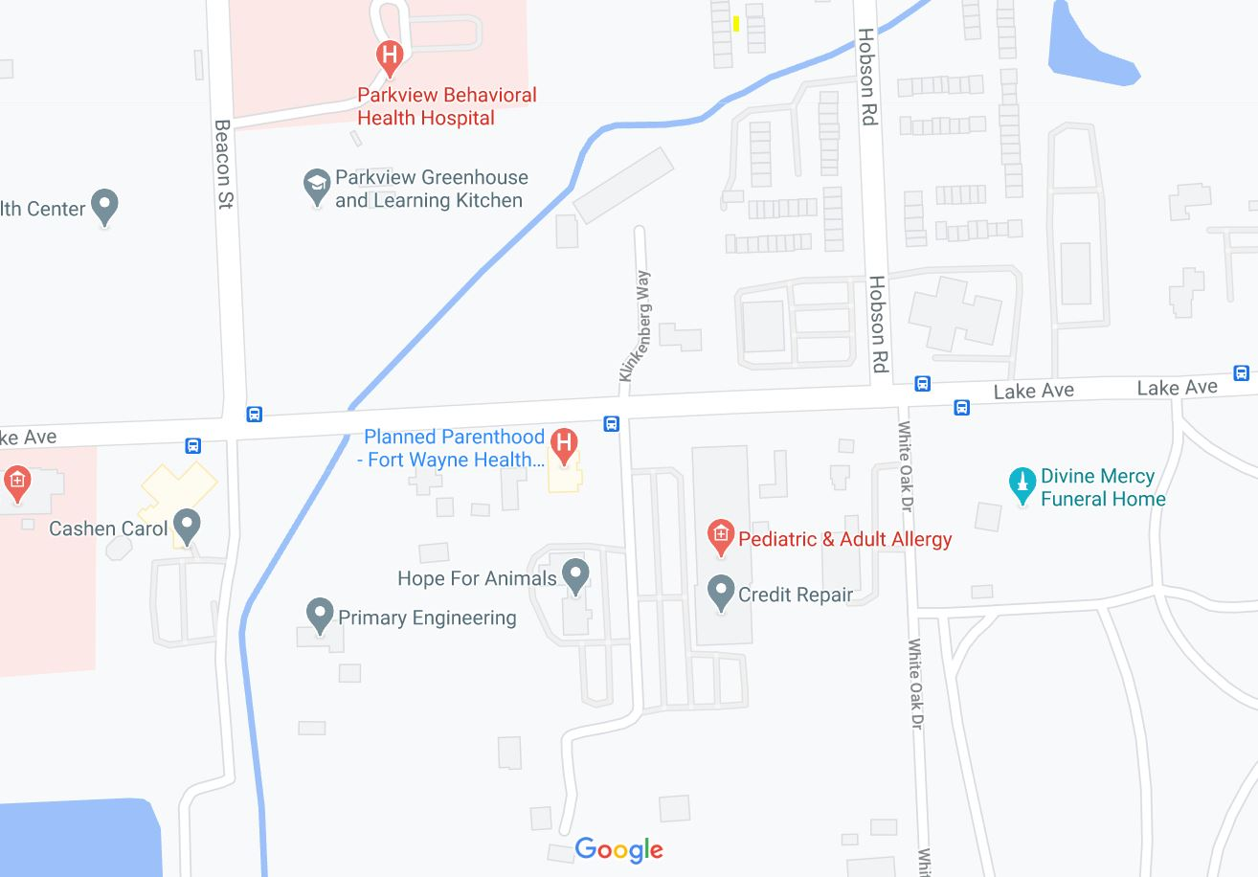
Thank you for participating in this year’s FALL 40 Days for Life! Please be sure not to block pedestrian traffic along the sidewalk during your vigil, especially people using the bus stop at the corner of Maycrest and Lake. Please only PARK and STAND in the areas marked in turquoise blue. Parking lots are marked with numbers. All other areas are private property. For questions, please call or text Annemarie at 260-797-3144
No Parking
1
2
3
NO PARKING OR STANDING HERE

